Real Stories of CFC Impact

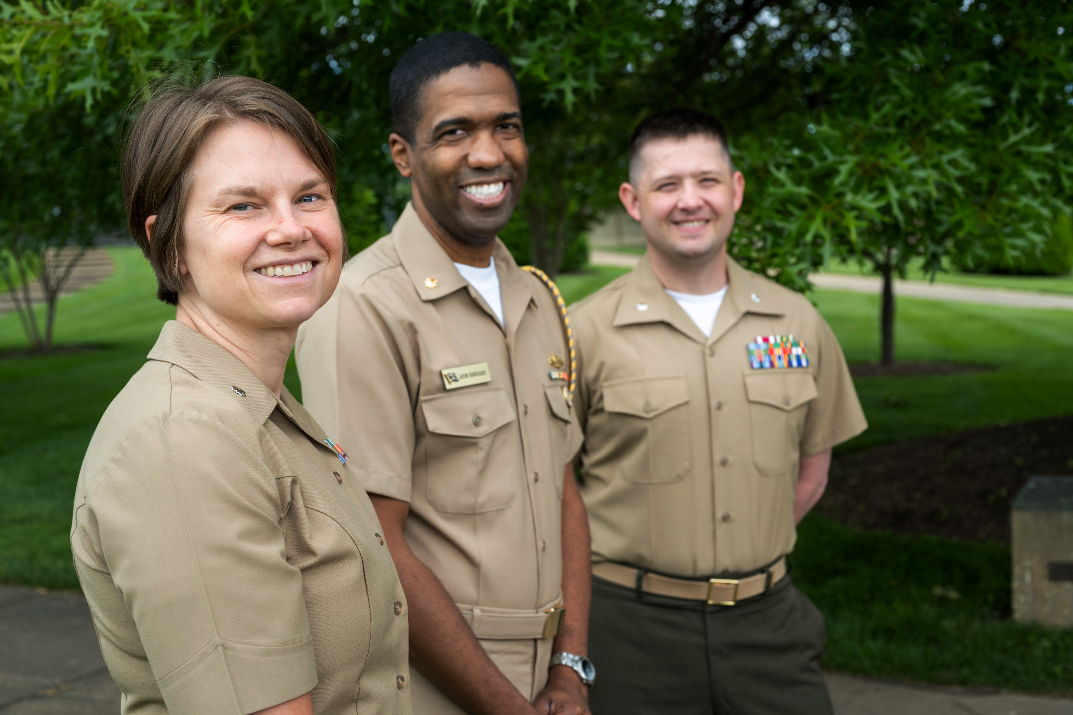
One of the benefits of the Office of Personnel Management’s (OPM) Combined Federal Campaign (CFC) is the collective impact donations have for people and communities in need. Federal employees and retirees giving generously together results in big checks going to charities, empowering their work to make a difference for good.

In 2020, it felt more important than ever to answer the urgent call of need. The federal community responded, taking the role of public servant even further with generous gifts to make a positive difference through the CFC. The challenges of the past year strained lives for countless individuals and families, but thanks to your donations through the CFC, charities were able to continue providing critical aid and essential programs to their beneficiaries.

Many CFC donors have a personal reason why they give back. “This past year has been tremendously tough for Americans – from natural disasters such as hurricanes and wildfires, to civil unrest, and of course, the unprecedented COVID-19 pandemic – all of these are adding up and they are taking a toll on the health and well-being of our service members and families,” said Lt Col Tongko, U.S. Air Force. Tongko gives to charities that support his fellow servicemen and women who are suffering increasingly due to the stresses of last year, and hopes to help “reduce stigma associated with seeking mental health [support] … and provide relief to those in need.”

People often have a common misconception that it takes an extraordinary person to care enough to give, but it’s more common than you think, and it’s easy! Even small donations can have a big impact:

$15 covers the cost of a one-hour recording session for artists to help strengthen their communities.
$20 removes on pound of trash from the ocean.
$30 trains 10 individuals to manage community risks and prepare for disasters.
$49 shelters a homeless child for a week.

The favorite way to give – payroll deduction through the online CFC Giving System – allows donors to pledge a little each pay period, adding up to an even bigger impact by the end of the year. Giving through payroll “[is] easy and provides my charity a constant income throughout the year,” said Gary Shoemaker, U.S. Department of Transportation.

The causes donors are passionate about often arise out of their own stories or those of a loved one. “I saw numerous CFC charities make contact with [a loved one] and offer support to the family [in a time of need] with food, support, and monetary help,” said Mark LaBombard, U.S. Department of the Navy. Donors interested in connecting more deeply to a mission and extending their spirit of service can watch charity videos and read charity success stories, participate in the Cause of the Week, engage at campaign events, celebrate the 60 years of the CFC with a supplemental one-time gift, volunteer, and more at GiveCFC.org.

